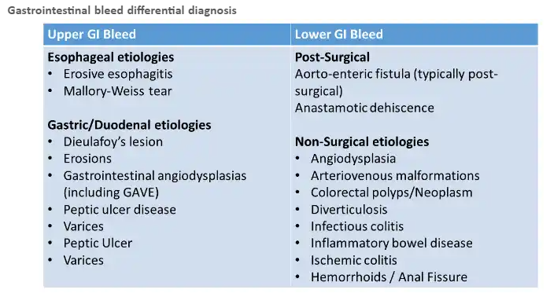

UPPER GI BLEEDING:
Prior to EGD | EGD | Post-EGD
Risk Stratification:  - ID Low-Risk pts  - Glasgow-Blatchford Bleeding Score  - Rockall Pre-Endoscopy Score  - AIMS65 Score  Resuscitation:  - Two 18-gauge+ IVs  - +/- 1 L crystalloid  - Packed RBCs if hgb < 7 g/dL (<8 g/dL if ACS)  Adjunctive therapy:  - Correct coagulopathy and hold AC  - Administer reversing agents +/- TXA  - Increase probability of good EGD:  --Pro-motility agent (e.g., erythromycin)  - Treat presumed underlying cause  - Stop offending agents (e.g., NSAIDs)  - Intravenous PPI  - IF c/f Variceal bleeding:  -- Vasoactive medication  (e.g., Terlipressin, Octreotide)  -- Antibiotic prophylaxis  (e.g., eftriaxone)  -- Balloon tamponade if uncontrolled | Time Frame:  - Perform within 24 hours for most hospitalized patients  - Perform within 12 hours for high risk patients (GBS > 8-12 or variceal hemorrhage)  - Sometimes can delay to >48hrs for low risk patients  Interventions:  - Clips or Thermal contact devices most common for ulcers  - Epinephrine should not be used alone  - Esophageal Varices need banding  - Gastric varices are typically treated with a tissue adhesive  (e.g N-butylcyanoacrylate)  Risk Stratification  - E.g: Forrest Criteria  - Help predict mortality and need for intervention | Medical Management:  PUD:  - High Dose PPI (cont vs BID)  - If high-risk Forrest classification: observe for 72 hours and c/w PPI BID dosing for 2 weeks  - If low-ris Forrest classification: may discharge with once daily PPI  Variceal hemorrhage:  - also start non-selective beta-blocker

