Diagnosis & Management of Pulmonary Embolisms
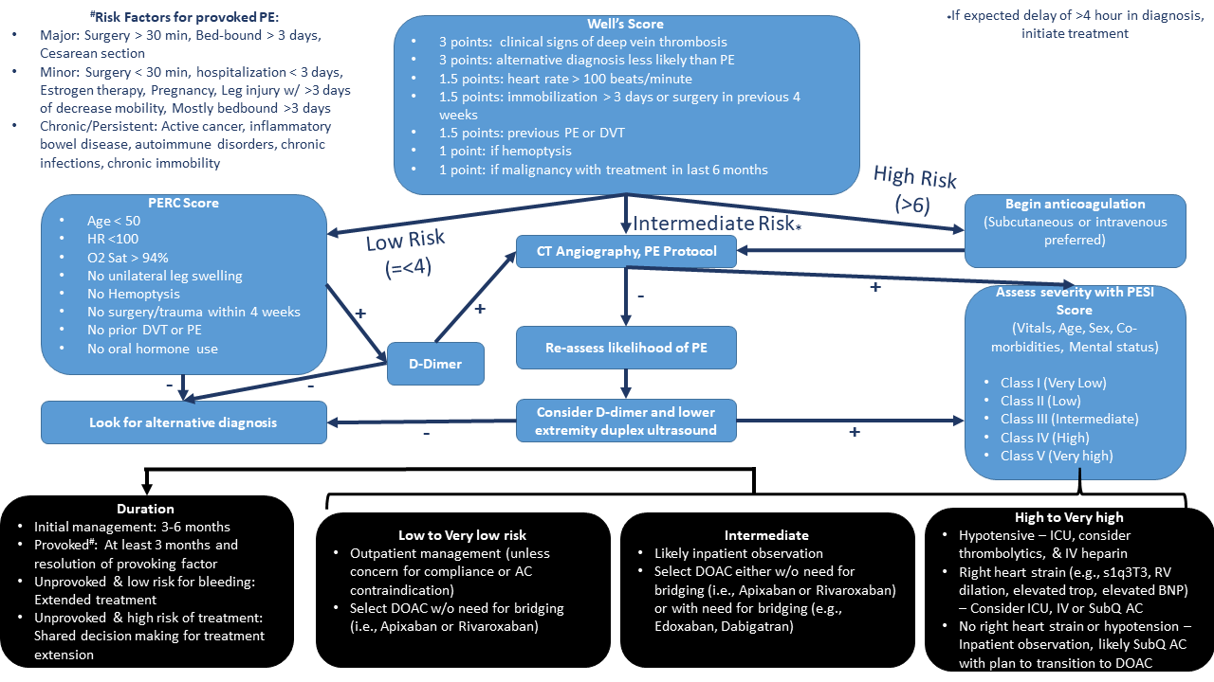

Principles of Management of Massive Pulmonary Embolism
Fluid Conservative Strategy | Aim for euvolemia. Fluid rarely helpful as venous pressure already high and additional fluids can cause worsening septal shift. Consider judicious fluids if IVC is small or collapsed jugular veins.
Low Threshold for Pressors | Goal is to decrease pulmonary vascular resistance and increase the systemic vascular resistance; target MAP >65.  - Epinephrine: Beta-agonist activity may assist with pulmonary vasodilation and improve contractility and chronotropic of the heart, improving CO and mitigating brady-asystolic arrest.  - Vasopressin: Causes systemic vasoconstriction and pulmonary vasodilation; both desired effects.  - Think about milrinone or dobutamine if you need inotropy.
Thrombolysis | Fibrinolytics are indicated for massive PE. There is unclear benefit in submassive PE. In the PEITHO Trial (NEJM, 2014): in patients with submassive PE being treated with unfractionated heparin, the administration of tenecteplase reduced composite endpoint of all-cause mortality or hemodynamic decompensation at 7 days when compared to placebo (2.6% vs 5.6%), but was associated with an increased rate of major bleeding (11.5% vs 2.4%).
Inhaled Pulmonary Vasodilators | Epoprostenol (@ 0.05 mcg/kg/min) vs Nitric Oxide (@ 20ppm). Oxygen is potent vasodilator -> so MUST correct hypoxia. Consider HFNC first; avoid intubation if possible as induction and positive pressure ventilation can be dangerous in RV failure (keep peak pressure low and minimize PEEP -> use high FiO2).
Advanced Interventions | - IR/Cardiothoracic Clot Extraction - *Get STAT CT Scan if concerned for submassive or massive PE to guide use of systemic thrombolysis or clot retrieval with IR or CT Surgery. Risk of death from massive PE is much higher than theoretical risk of contrast nephropathy.  - VA ECMO cannulation for RV rescue (if time, facility resources, cannulation capabilities allow)

