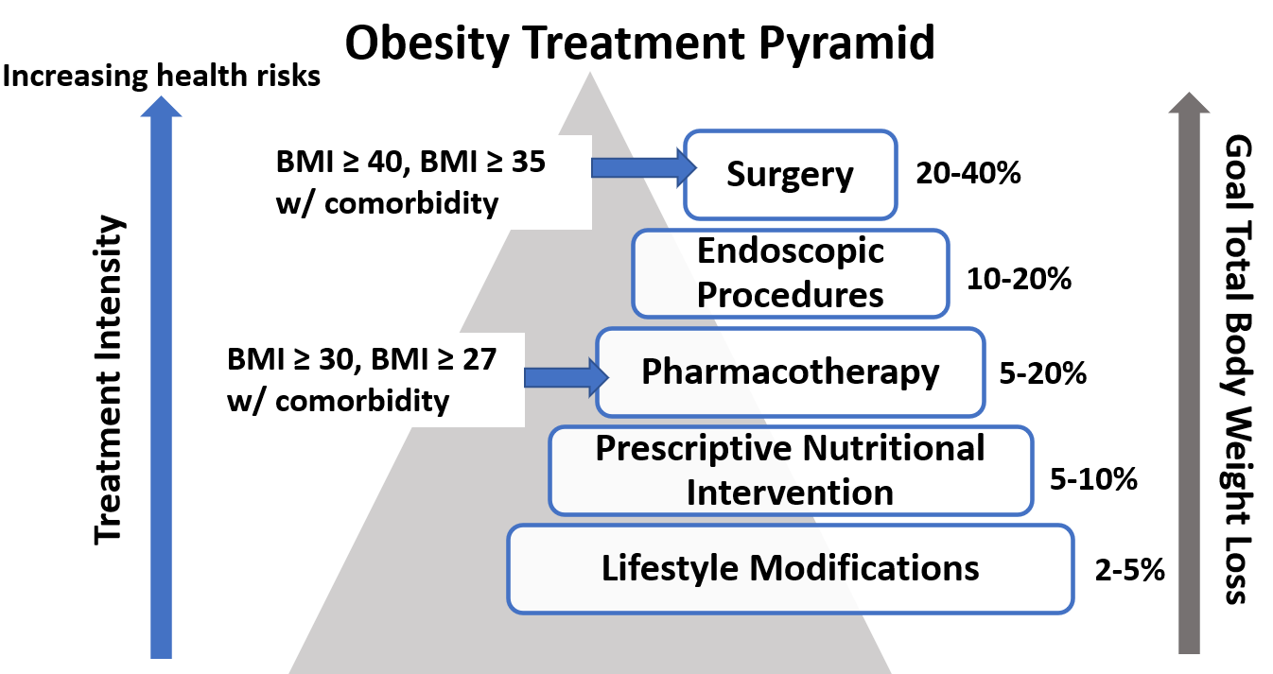

Evaluation

Nutritional history – 24hr recall
- Eating habits/time/portions
- Cravings, hunger, binging
- Emotional eating
- Alcoholic or sugary beverages
- How many times do you eat out per week
Physical activity
Sleep quality and quantity _ STOP-BANG
Stress
Weight history - Highest & lowest weight
FMH obesity
What has worked in the past

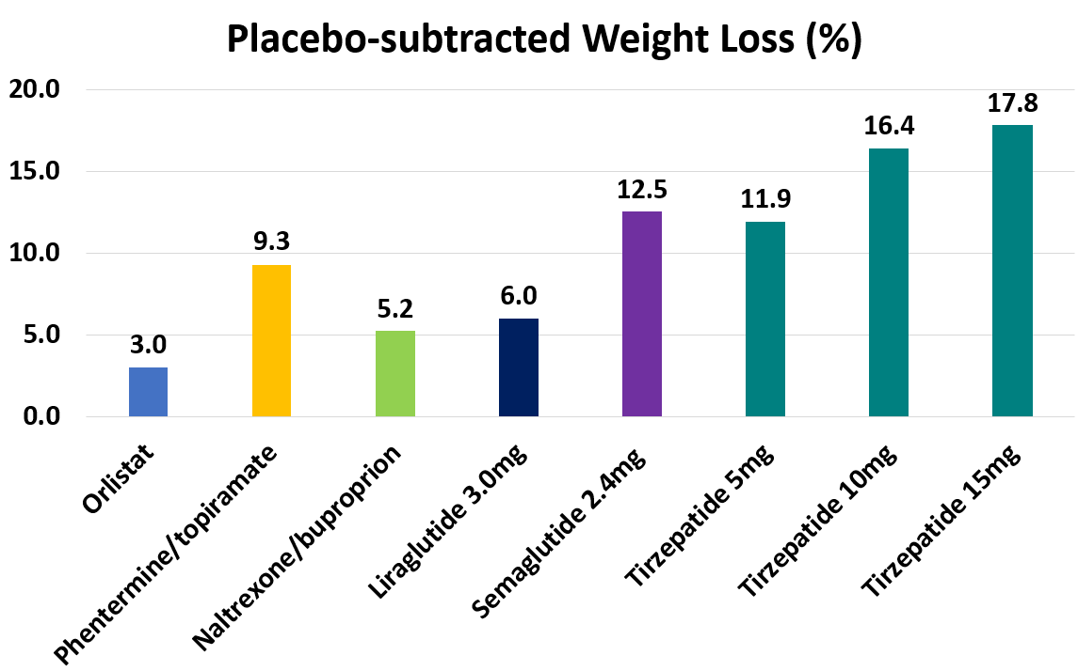
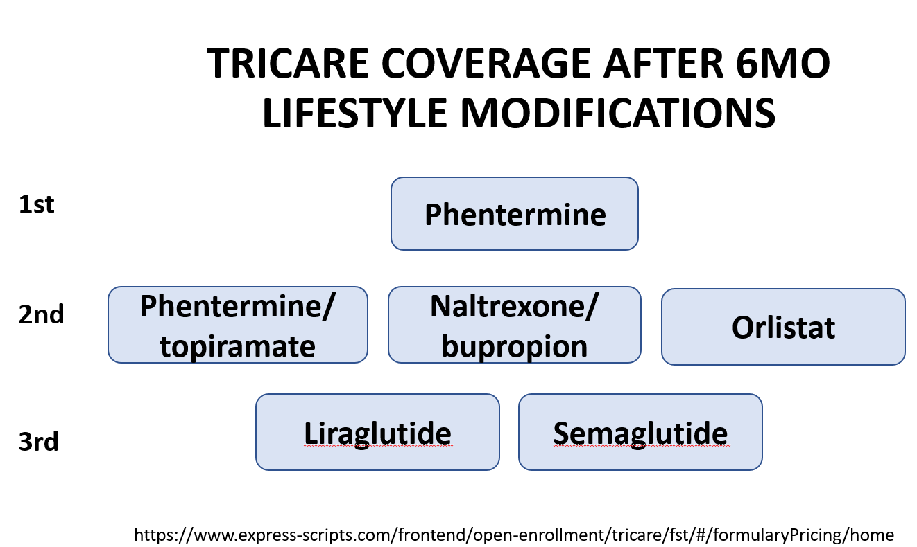

Other Options:
- Metformin
- Other GLP1-agonists (dulaglutide)
- Topiramate
- Gelesis (Plenity) – FDA approved device

Weight gain/loss side effects of commonly used medications

